**PayProcessMD**

Doctor’s payroll processing, done right.

**User Guide**

**v1.0**

Asian Hospital and Medical Center 2018

**1. Overview**

PayProcessMD is an on-premise web application that is built to process doctors’ payroll. It is based from the current doctor’s fee system but is more highly optimized, user friendly, accurate and flexible. This application requires internet connection and can be accessed via this url, <http://payprocessmd>.

**2. Application Core**

PayProcessMD is simply divided into 4 core divisions.

REPORTS

UPLOADING

PROCESSING

MAINTENANCE

**2.1 Maintenance**

**A.** Login

PayProcessMD is designed to authenticate user against the Active Directory so users need to obtain a domain account to access this system.

**B.** User Request

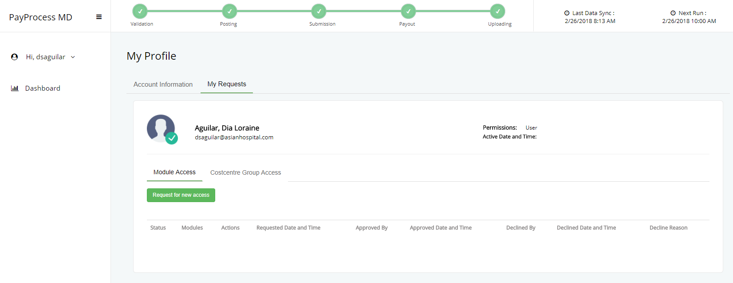

A domain account does not guarantee an automatic access to the system so users need to request for access to either one or multiple modules and actions. The domain account’s password is required for every request made to ensure the user’s identity. Once the request is approved, user can now login and any other additional request for access can be done inside the system (as shown in Image B.2). Each request sends an email notification to both requestor and approver.

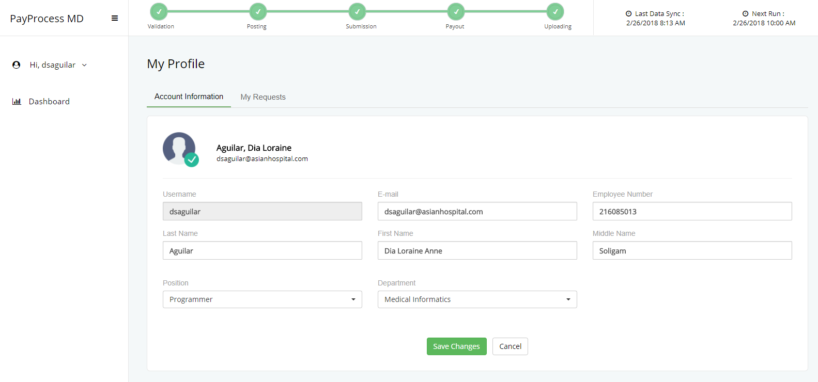**C.** User Profile

User information is vital to the system so users need to complete their details in the User Profile Module once logged in. For employees who owns an Orion HIS account, the system will auto-fill the required fields, in case the information from the HIS is not updated, the user can modify and save his changes. The system will detect any incomplete detail in the User Profile module and will prompt the user to fill it up for every login.

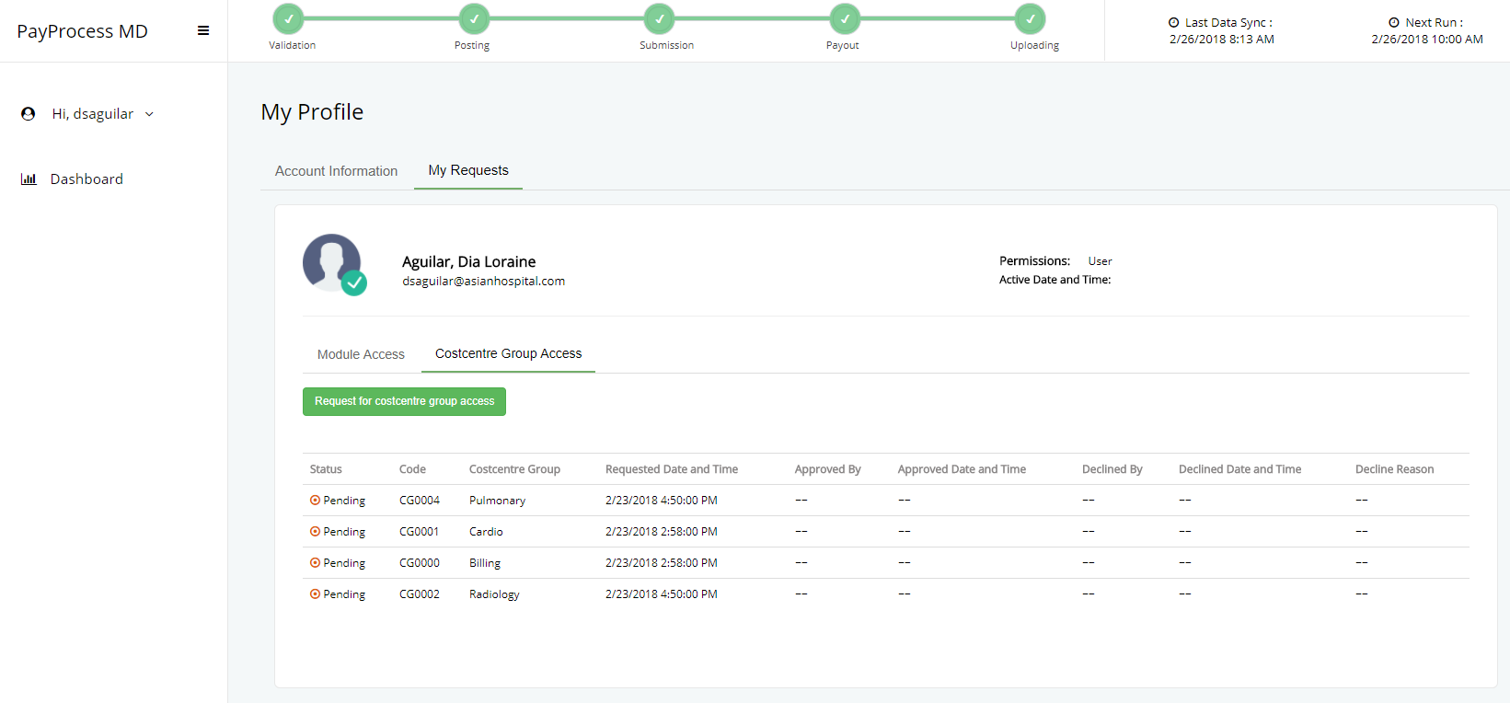**D.** Costcentre Group

User’s default costcentre group is automatically identified based on the deparment specified in User Profile module. When the need arises, user can request for multiple cosstcentre group. An email notification will be sent to both the requestor and approver.

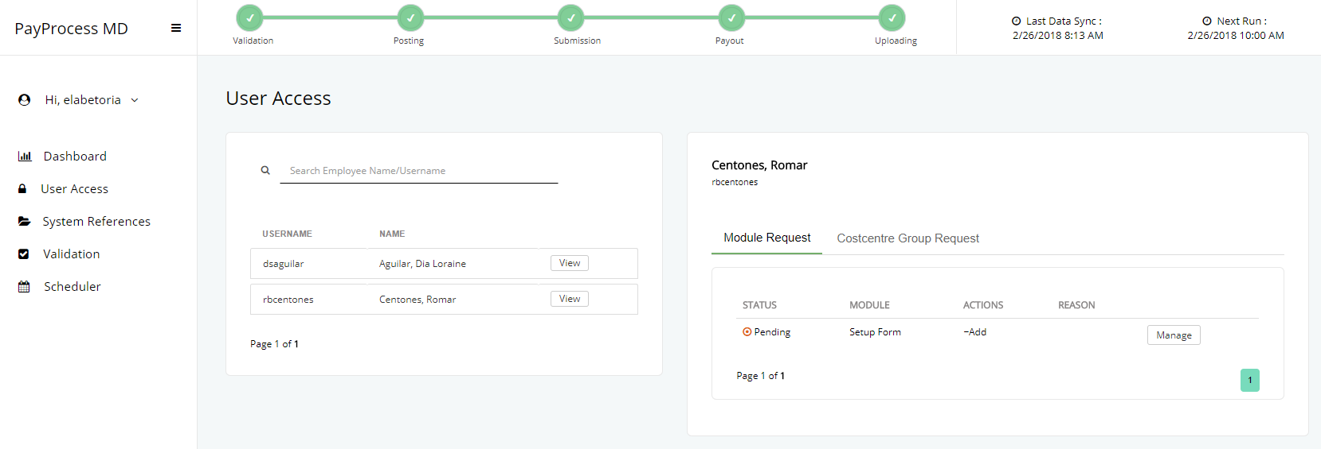**E.** Request Approval

Assigned approvers for each module and costcentre can view all the requests in this module. The approver can either approve, modify or decline a pending request. On the other hand, approved requests can either be revoved or modifed while revoked requests can still be modified and reactivated. Just take note that declining or revoking a request requires a reason from the approver. An email notification will be sent to the requestor regarding the status of their request.

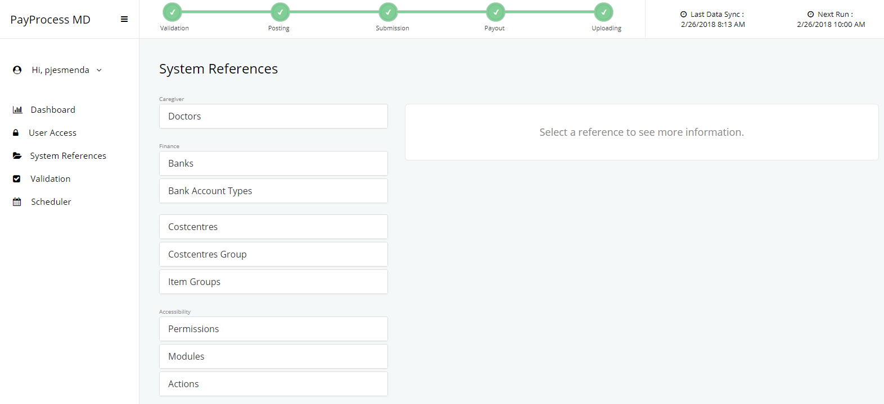**F.** System References

All references for the PayProcessMD can be found in the System References module. This allows the system to be flexible and dynamic. In this module, authorized user can create and update doctors’ bank accounts, update their vat and withholding tax rates.. User can also create and update costcentre groups, tag item groups as exclusive to a certain costcentre group, assign approvers to system’s modules and more.

**2.2 Processing**

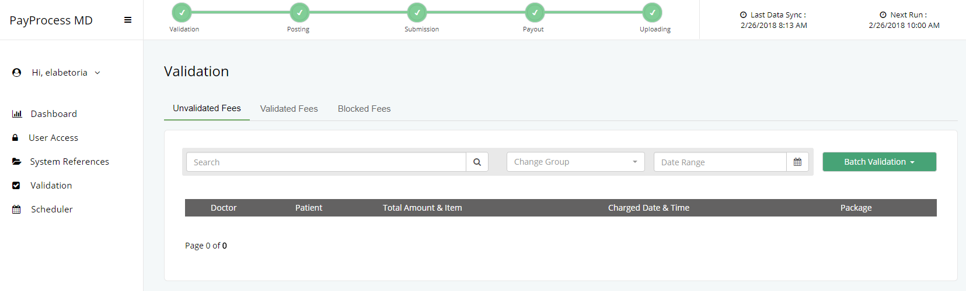**A****. Validation**

The validation module is considered as the starting point of PayprocessMD. It is consists of three tabs namely Unvalidated Fees, Validated Fees and Blocked Fees. Each tab is provided with search, costcentre group and date range filters while column sorting is limited to ‘Doctor’, ‘Patient’, and ‘Charged Date’ fields. If the user wishes to see the complete details of a certain item, a sidebar is displayed once the user clicks anywhere on the table row.

`**User Actions**

* Validate – allows user to validate fees or revert validated fees back to its original state (unvalidated) or modify the assigned doctor.
* Block – allows user to block or unblock fees, modify the assigned doctor.
* Read – allows user to view items.

All validated and blocked fees with a ‘Pending’ status for posting can still be modified while those that are already ‘Posted’ cannot be altered since those are already subject for processing. Lastly, the system also keeps track of every action made upon the item which can be viewed in the audit trail.

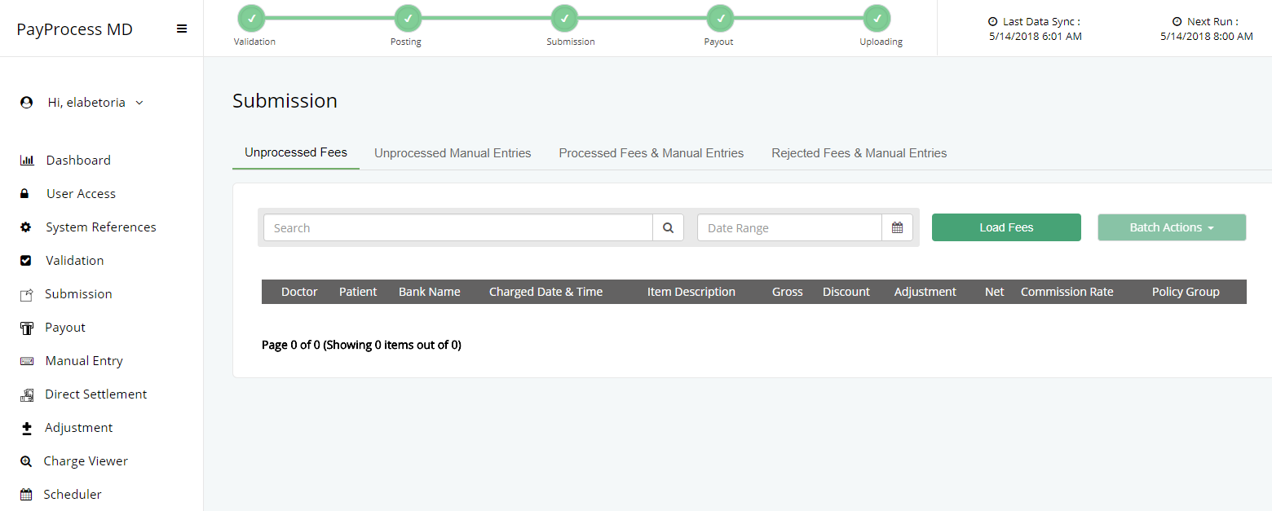**B. Submission**

Processing starts as soon as the user loads fees that are already posted and passed the criteria for submission.

**Criteria for Processing and Submission**

* A charge item should have an invoice and remittance details.
* For S23 items, an invoice should be paid (Completed).
* An invoice should not have any pending adjustments.
* A remittance should have a transaction status of ‘PSL (Posted to Subsidiary Ledger)’ or ‘POS (Posted to General ledger)’ in the system.
* The assigned doctor for the item should have an updated vat/tax mapping.

Submission module is consists of four tabs namely Unprocessed Fees, Unprocessed Manual Entries, Processed Fees and Manual Entries and Rejected Fees and Manual Entries. Each tab is provided with search, costcentre group and date range filters while column is sorting is limited to ‘Doctor’, ‘Patient’, and ‘Charged Date’ fields.

**User Actions**

* Submit – allows user to process or reject fees and manual entries or revert them back to its original state (unprocessed). Submit items for payout.
* Read – allows user to view items.

Upon submission, the system processes the items and makes the necessary computations required for payout. All these actions are tracked and can be viewed in the audit trail.

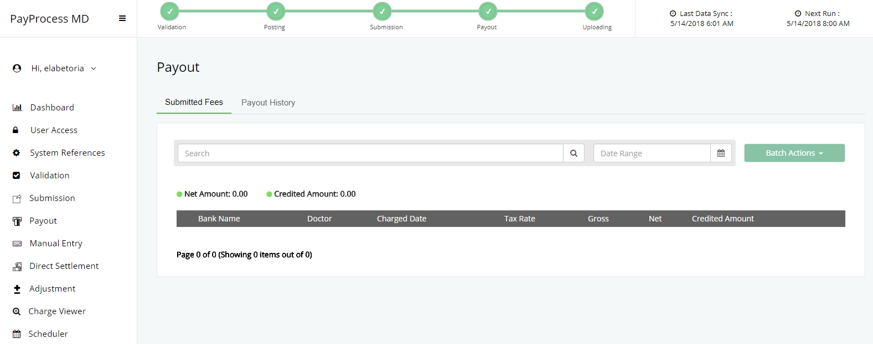**C. Payout**

Processing ends in Payout module. It is consists of two tabs namely Submitted Fees and Payout History. Each tab is provided with search filter while Submitted Fees Tab has an additional date range filter and column sorting limited to ‘Doctor’ and ‘Charged Date’ fields.

**User Actions**

* Payout – allows user to payout fees to generate text file needed for uploading.
* Read – allows user to view items.

All previously paid periods can be accessed in Payout History tab. It also allows user to credit back a certain fee that is either rejected by the bank due to an outdated bank account or having no bank account details when the payout was made. Lastly, this is where users can generate a text file for uploading to the accredited bank.

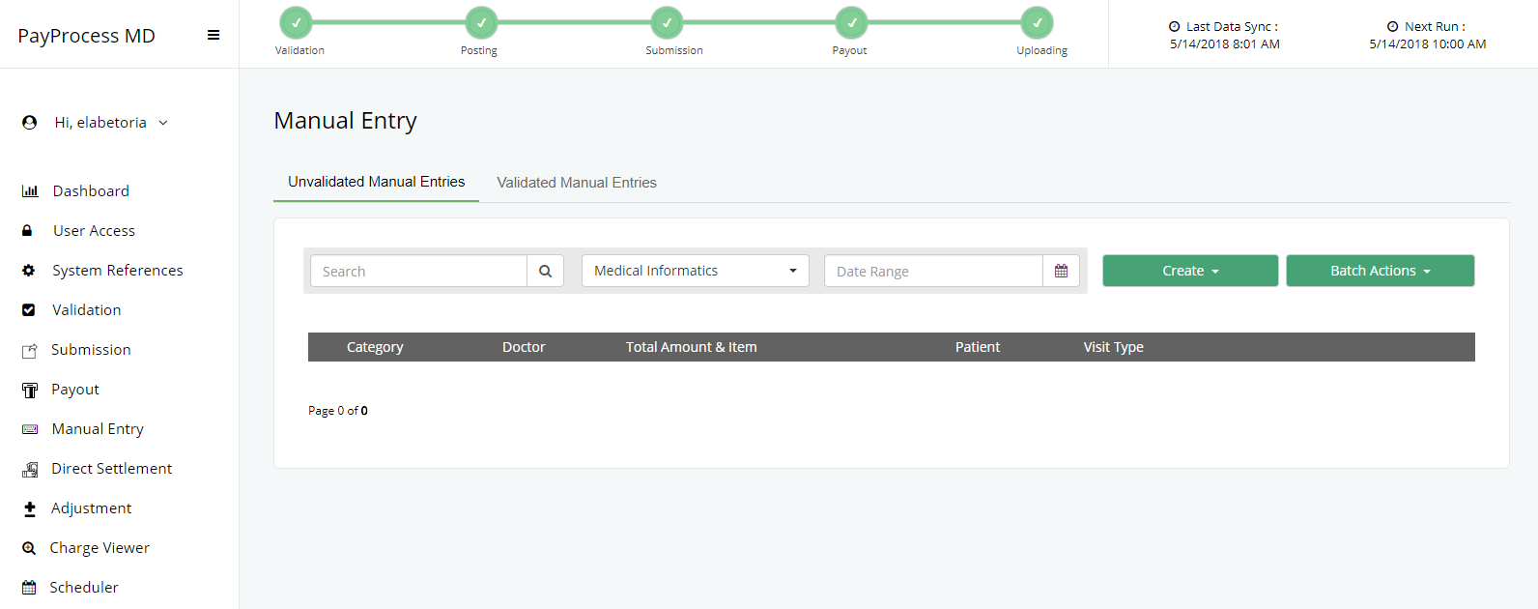**D. Manual Entry**

This module allows user to create fees not captured by the Orion HIS that should be included in payout. There are two types of manual entry, non-patient related and patient related. Non-patient related entries are for on-call staff and other employees whose payroll aren’t processed in ESS. On the other hand, patient related entries are for professional fees that either has an adjustment or, as mentioned earlier, was not captured by Orion HIS. Manual Entry module is consists of two tabs namely Unvalidated and Validated Manual Entries. Each tab is provided with search, costcentre group and date range filters while column sorting works in all fields except the ‘Total Amount & Item’ field.

**User Actions**

* Add – allows user to create an entry.
* Edit – allows user to modify an entry.
* Delete – allows user to delete an entry.
* Validate – allows user to validate an entry.
* Post – allows user to post an entry and be subject for processing.
* Read – allows user to view items.

An entry can be created anytime in the system and all actions made are tracked and can be viewed in the audit trail.

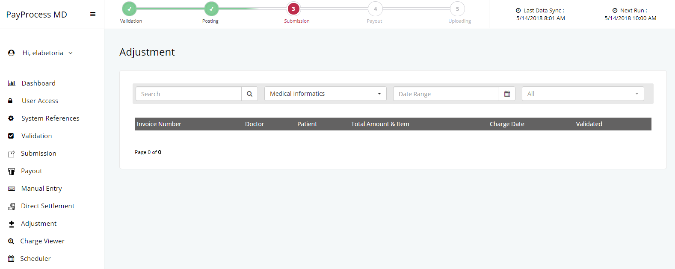**E. Adjustment**

Users can create a debit or credit adjustment for invoices in this module however, an adjustment should be approved so that it will reflect on the item upon processing. And to guide users, the system shows the summary of adjustmenst made to avoid reaching a negative balance amount. The system keeps track of all the actions made and can be viewed in the audit trail.

**User Actions**

* Add – allows user to create an adjustment.
* Edit – allows user to modify an adjustment.
* Delete – allows user to delete an adjustment.
* Approve – allows user to approve or reject an adjustment.
* Post – allows user to post an adjustment for processing.
* Read – allows user to view items.

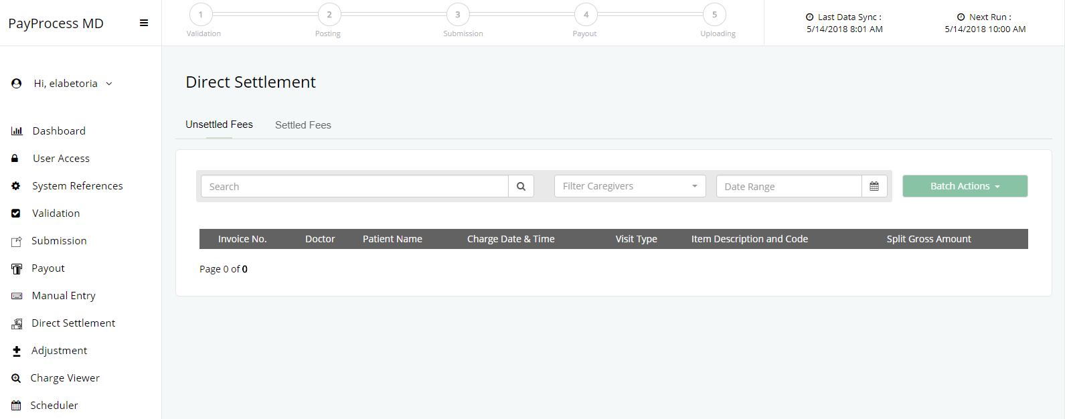**F. Direct Settlement**

This module allows user to tag an invoice as directly settled by the patient so that it won’t be included in processing and payout.

**User Actions**

* Direct Settle – allows user to direct settle an invoice, revert or post the action made.
* Read – allows user to view items.

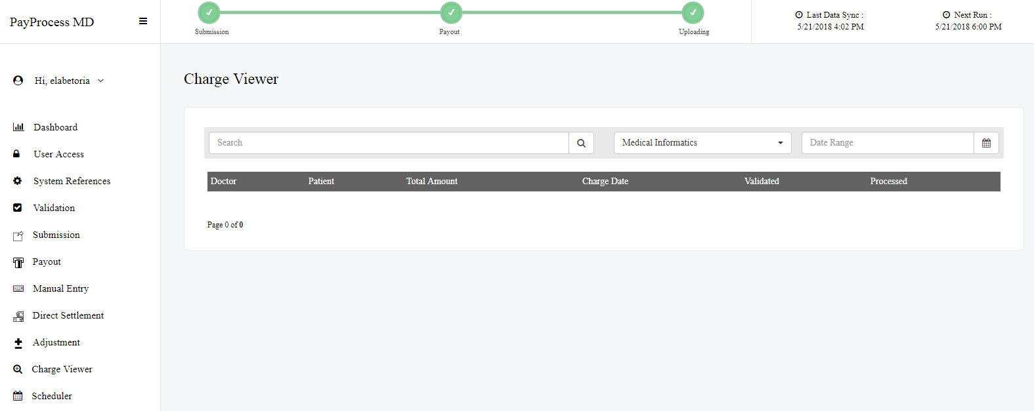**G. Charge Viewer**

This module allows user to search for a certain charge and view the information related to it including the details of validation, direct settlement, adjustment, processing and etc. It is provided with search, costcentre group and date range filters.

**User Actions**

* Read – allows user to view items.

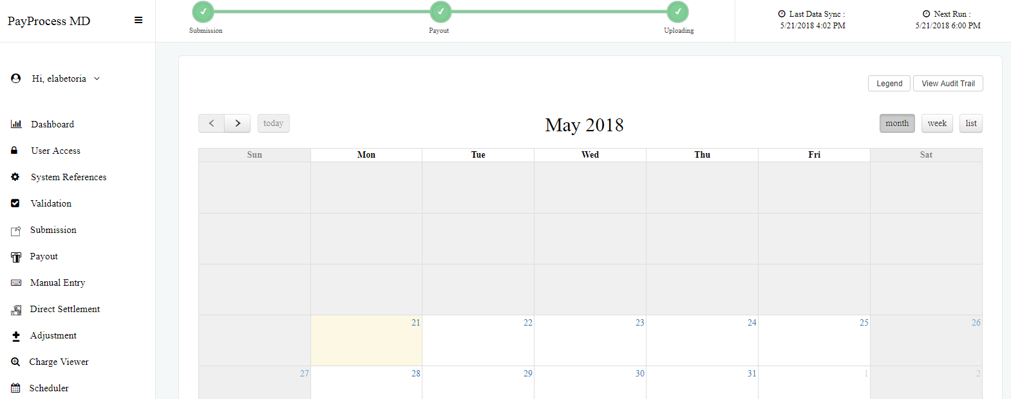**H. Scheduler**

The scheduler module is designed so that the system follows a clear schedule from submission to payout up to uploading. This allows one schedule per week, each of it includes Processing Date, Payout Date and Credit Date as well. Upon payout, the system sets the current active schedule as completed and automatically changes the status of the next one as active unless none is defined. Furthermore, a progress bar is displayed on the center top part to guide user with regards to the status of the current processing.

**Progress Bar / Schedule Status**

* Green – Completed
* Blue – Active (Current)
* Yellow - Pending

**User Actions**

* Read – allows user to view schedules.
* Schedule – allows user to create, edit and delete schedule.

**2.3 Uploading**

Uploading is the final process for the doctor’s payroll, this is where the system generates a text file that corresponds to the format and the standards of the accredited bank.

**2.4 Reports**

PayProcessMD provides reports to relay structured information to its users. As of now, the system has four available reports which can be viewed in <http://itworksdev01/reports>.

* Payment Remittance Advice – shows the details of all the payments that a doctor has received for a specific payout date.
* Doctor Credited Payment - shows all the payment details that a doctor has received from a certain date range.
* Paid Invoice, Unpaid Doctor – shows the details of all paid invoices that are not yet credited to doctors.
* Unpaid Invoice, Paid Doctor – shows the details of all unpaid invoices that were credited to doctors.